**OBJECTS AND THEIR INTERNAL REPRESENTATION IN JAVASCRIPT**

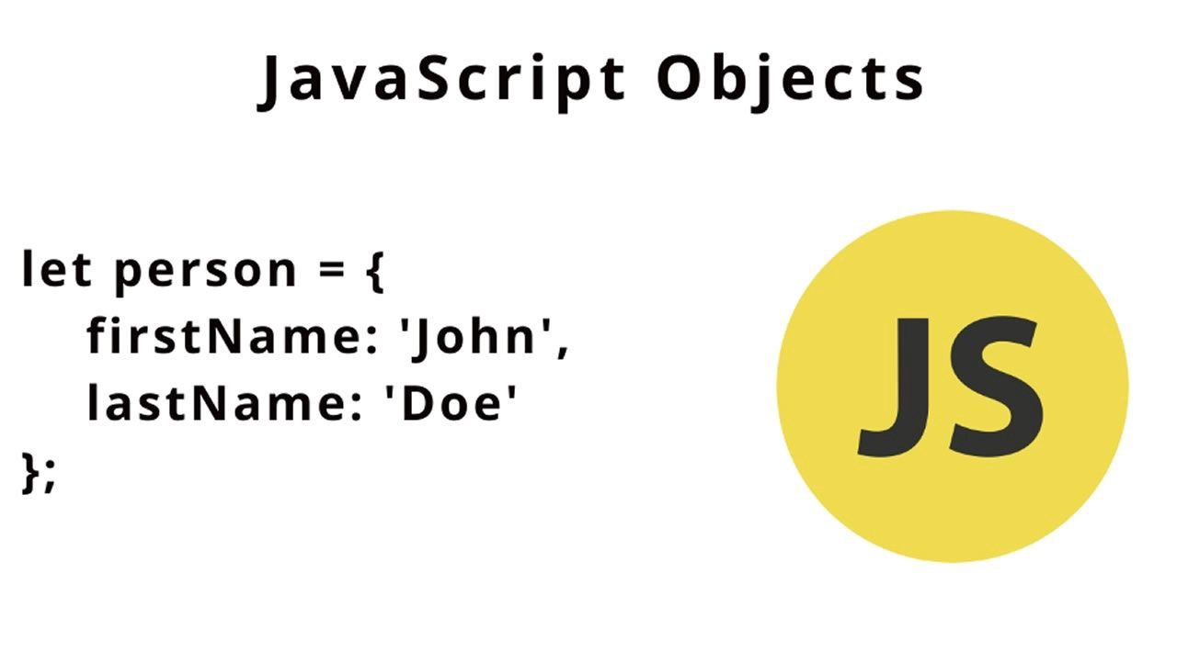

Objects are the composite data types in JavaScript. They are used for storing data in key-value pairs. In JavaScript almost everything is an object. The structure of an object is as follows

* *let obj = { name : “something”, age : 23 }*

Here, ‘name’ is the key, “something” is the value and similarly ‘age’ is the key and 23 is the value for it. Objects can contain same data types or different data types or even nested objects as key value pairs. See the below example

*let obj =*

{ name : “something”,

age : 23,

languages : [‘english’, ‘hindi’, ‘telugu’, ‘marathi’], // languages array

transport : { car : 1, bike : 1, carName : ‘lambo’, bikeName : ‘honda’ }

}

In the above code, we can see a ‘transport’ object inside ‘obj’ object. That’s how we can declare nested objects. To access the elements in obj read the below paragraph

To access a property in objects give ‘objectName.key’ or ‘objectName[“key”]’. For Example

obj.name // gives string “something”

obj[“name”] // same as obj.name

obj.age // gives number 23

obj.languages // gives languages array

obj.transport.car // gives 1 which is assigned to key ‘car’ in ‘transport’

obj[“transport”] [“car”] // same as obj.transport.car

**We can also assign the values of objects to the variables**

let cars = obj.transport.car;

let carName = obj.transport.carName;

let en = obj.languages[0]; //gives “english”

Thanks for Reading !!!